**Raspberry Pi Marine Heatwave Simulator project**

Amelia Ritger



This work is licensed under the [Apache License 2.0](https://github.com/ameliaritger/MHWsim/blob/main/LICENSE).

**Contents**

1. Introduction
2. Materials, Tools, and Consumables
3. Preparing the Raspberry Pi
4. Preparing the Relay HAT
5. Preparing the Perma-Proto HAT
6. Assembling the system
7. Adapting the code to your experiment

**1. Introduction**

Ocean acidification monitoring efforts are a crucial component of tracking the impacts of climate change in marine ecosystems. However, the high instrument cost presents a major barrier to the production of scientific knowledge and has resulted in a highly fragmented understanding of the global progression of acidification. Our project built upon an existing nearshore marine pH sensor design which utilizes a Durafet pH electrode. Our goal was to lower barriers to access by significantly lowering the cost of, and improving approachability to, the design and use of pH sensor electronics. We have created a more compact design using open-source components based on the popular and easy-to-use Arduino platform that eliminates over $900 from the cost of the sensor electronics. We demonstrate with lab and field testing that switching to Arduino-based sensor electronics maintains high data fidelity. Our design supports open science by allowing more individuals and research groups to engage in high-quality oceanographic research.

This document provides guidance on the construction of the Raspberry Pi Marine Heatwave Simulator system. ***This document is an early work in progress, please stay tuned for updates!***

**2. Materials, Tools, and Consumables**

|  |  |  |
| --- | --- | --- |
| **ITEM** | **QUANTITY** | **PRICE** |
| **Tools** | | |
| Soldering iron | 1 | varies |
| Wire strippers | 1 | varies |
| Needle nose pliers | 1 | varies |
| Flat head and Phillips head screwdriver | 1 | [$1.50](https://www.adafruit.com/product/3284) |
| Razor blade | 1 | [~$5](https://www.amazon.com/Single-Edge-Razor-Blade-Pack/dp/B08FW6CYG5) |
| **Materials** | | |
| Raspberry Pi 4 (4GB) | 1 | [$55](https://www.digikey.com/en/products/detail/raspberry-pi/SC0194-9/10258781) |
| microSD card (32GB+) | 1 | [~$10](https://www.amazon.com/SanDisk-Ultra-microSDXC-Memory-Adapter/dp/B073JWXGNT/) |
| RPi Relay Board | 1 | ~[$18.99](https://www.amazon.com/gp/product/B07CZL2SKN) |
| Perma-Proto HAT | 1 | [$4.95](https://www.digikey.com/en/products/detail/adafruit-industries-llc/2310/5629417) |
| DS18B20 waterproof thermistor | 1 | [$11.95](https://www.digikey.com/en/products/detail/sparkfun-electronics/SEN-18367/15189222?s=N4IgTCBcDaIIwFYBsAOAtAZQKIDk1xQGYkB2NHAERAF0BfIA) |
| 1/8-1/4W 2.2-4.7k $Ω$ resistor | 1 | [~$0.10](https://www.digikey.com/en/products/detail/lumimax-optoelectronic-technology/CF1-4W2K2JTB/16708111) |
| Extension cord | 1 | [~$6](https://www.homedepot.com/p/10-ft-16-3-SJTW-13-Amp-125-Volt-1625-Watt-Lighted-End-Indoor-Outdoor-Black-Heavy-Duty-Extension-Cord-16310FTBK/314613505) |
| RPi waterproof housing | 1 | varies |
| **Consumables** | | |
| Lead-free solder | 1 | [$6.75](https://www.digikey.com/en/products/detail/nte-electronics-inc/83-7068-1402/12158031) |
| 22 AWG solid core wire | 1 | [$2.95](https://www.digikey.com/en/products/detail/adafruit-industries-llc/290/6226989) |
| Nylon screws | 1 | [$14.95](https://www.digikey.com/en/products/detail/adafruit-industries-llc/3658/8258465) |

**3. Preparing the Raspberry Pi**

Set up your Raspberry Pi (‘RPi’) following the [tutorial](https://projects.raspberrypi.org/en/projects/raspberry-pi-setting-up/0) by the Raspberry Pi Foundation. Once you have communication with your RPi established, you can begin adding more complex features such as remote access and text alert notifications. Otherwise, begin assembling your system.

Note: it is highly recommended that you get your RPi set up on WiFi, unless you plan to use a more permanent, dedicated screen for viewing the desktop environment of your RPi. Read this documentation for setting up your RPi on a wireless network:

<https://www.raspberrypi.com/documentation//computers/configuration.html#the-raspi-config-tool>.

If you are in academia and your campus has an eduroam network, follow this tutorial for getting your RPi connected to eduroam WiFi: <https://inrg.engineering.ucsc.edu/howto-connect-raspberry-to-eduroam/> Note: campus WiFi connections are finnicky, and you very likely will need to contact your campus/department IT services if you are having issues connecting your RPi to campus WiFi.

Once you have a wireless network established, follow this tutorial for setting up VNC remote access on your RPi: <https://magpi.raspberrypi.com/articles/vnc-raspberry-pi>.

If you want to set up text alerts with your RPi (in case of any sensor failures), read through this post: <https://iotdesignpro.com/projects/sending-smtp-email-using-raspberry-pi> and this forum post: <https://forums.raspberrypi.com/viewtopic.php?t=284519>. Note: you will need to create an email address for your RPi in order to do this - you do not want your personal or work email to be at risk for hacking attempts!

**4. Preparing the Relay HAT**

Power to the heaters and chillers is controlled via the relay HAT. To protect the wiring of the heaters and chillers, you will be joining the heaters and chillers to the relay HAT via extension cords. Carefully cut the external sheath of the extension cord with a razor blade to expose the inner wires. Try not to cut through the external wires. Note: If you cut all the way through the wires, you will need to keep them separated with electrical tape (or even better, shrink tubing). There should be three different colored wires – black (power), green (ground), and white (neutral) (Figure FF). Cut the black (power) wire and use wire strippers to expose the stranded wire core. Note: Adding solder to the ends of the wires will keep the strands organized. The Relay HAT I used has three channels (but you can find Relay HATs on Amazon with more or less channels, depending on your needs), each with a screw terminal block. Thread one end of the extension cord black wire to “NOx” and the other into “Cx” on one of the blocks, and secure by tightening with a flat head screwdriver (Figure EE).

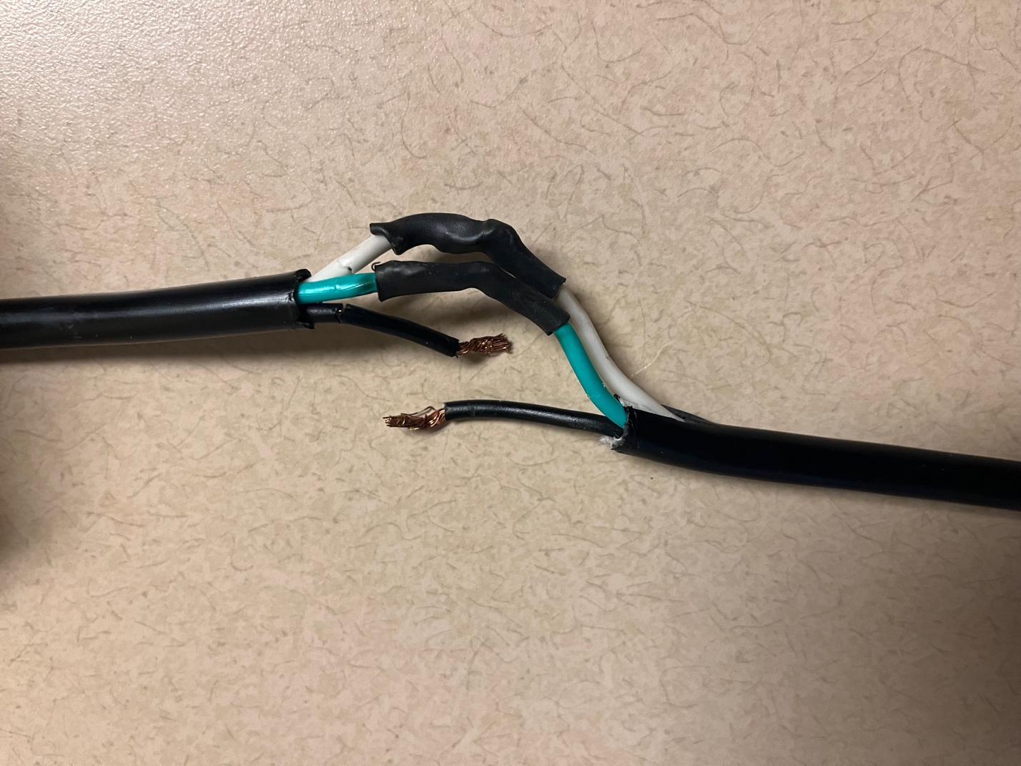

Figure FF. The inner wires of an extension cord. The black wire (power) will be connected through the Relay HAT. Any exposed wire core from the non-power wires is protected with black shrink tubing.

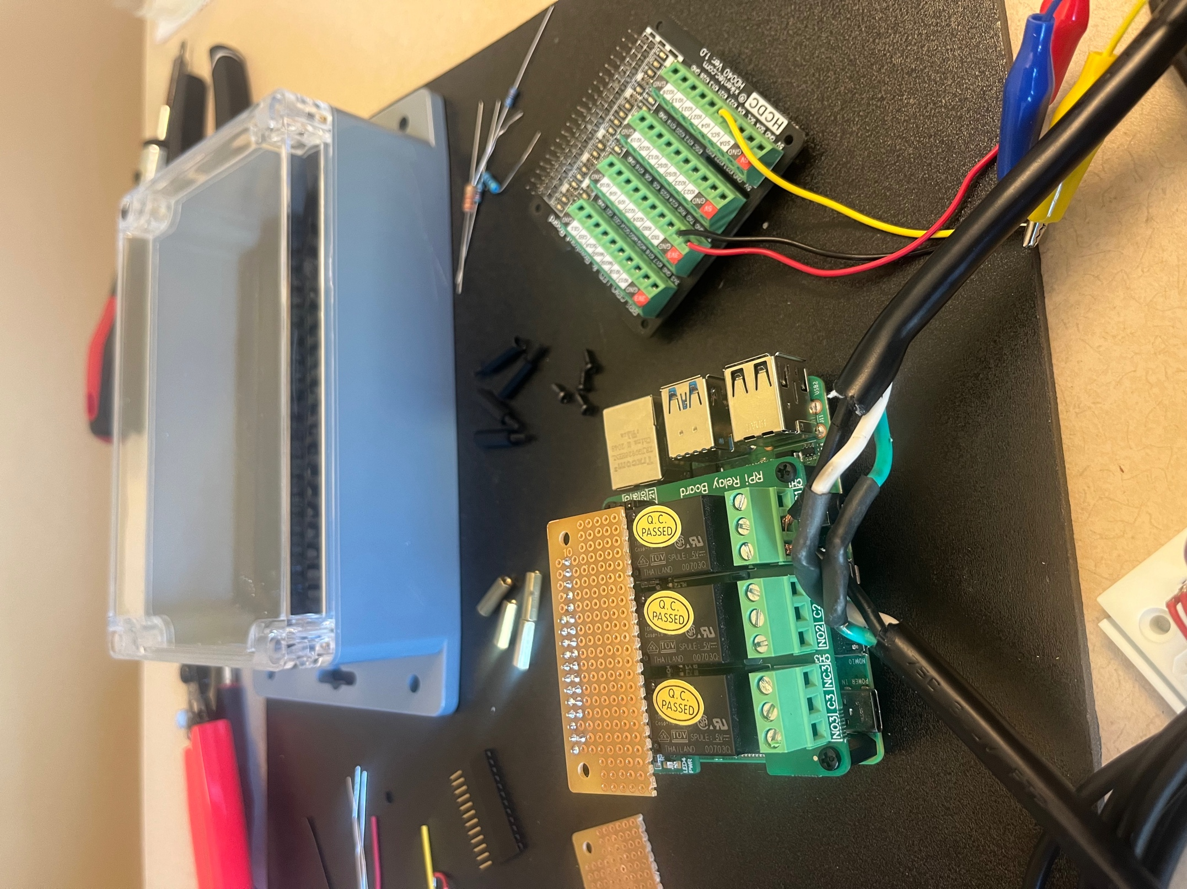

Figure EE. One extension cord plugged into a screw terminal on the Relay HAT.

**5. Preparing the Perma-Proto HAT**

The DS18B20 thermistors are connected to the Raspberry Pi via the Perma-Proto HAT. The thermistors come with three wires VDD (red), GND (black), and GPIO (white/yellow) (Figure AA).

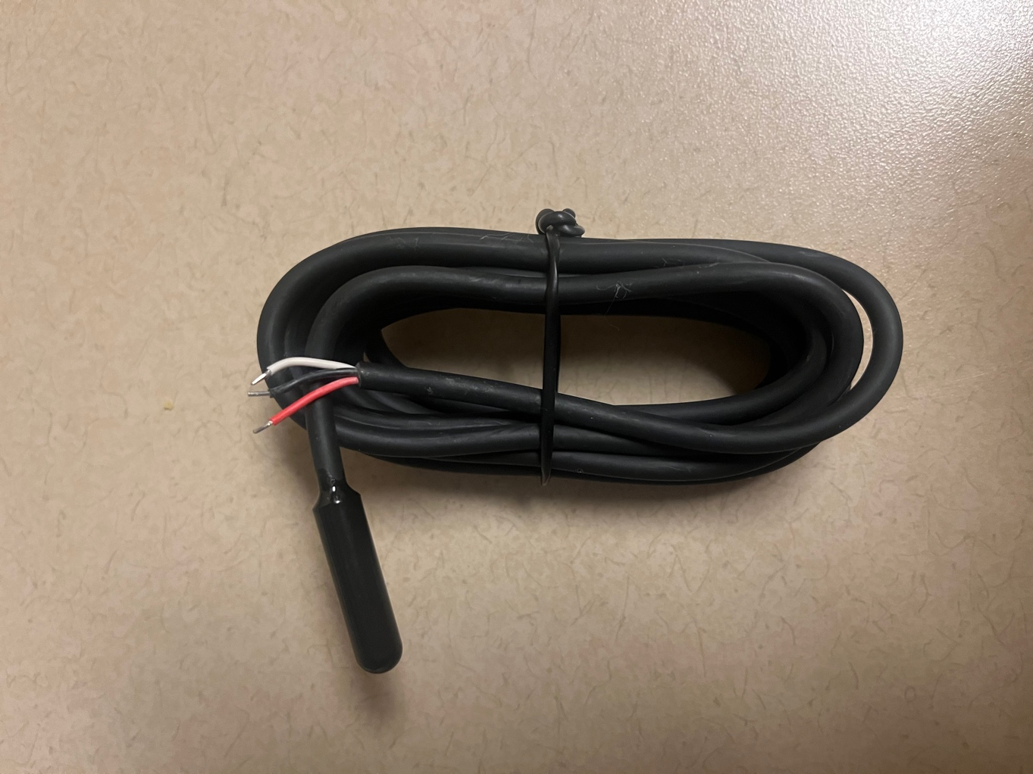

Figure AA. New DS18B20 thermistor with exposed wires, ready to be soldered.

Solder the header to the top row of the HAT, and then solder the various components to the Perma-Proto HAT following the schematic in Figure BB. Strip solid core wire and connect it each of the connections to the RPi headers (blue lines in Figure BB), and for applications with multiple thermistors, use stripped solid core wire to connect like wires across the board (orange lines in Figure BB). Solder a 1/8W 4.7k $Ω$ resistor between the VDD and GPIO lines, as shown in Figure BB. A complete example, with 18 thermistors and a 1/4W 3.2k $Ω$ resistor, is shown in Figure CC. Note: the more thermistors you add to the system, the greater the wattage and lower the resistance value you need for your resistor.

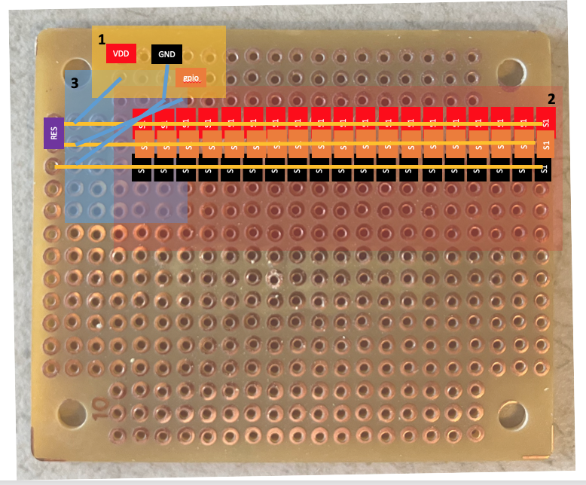

Figure BB. Perma-Proto HAT with locations for thermistor wires (region 2), resistor (region 3), and connections to the RPi header (region 1) to be soldered. It is recommended to solder region 1 first and region 3 last.

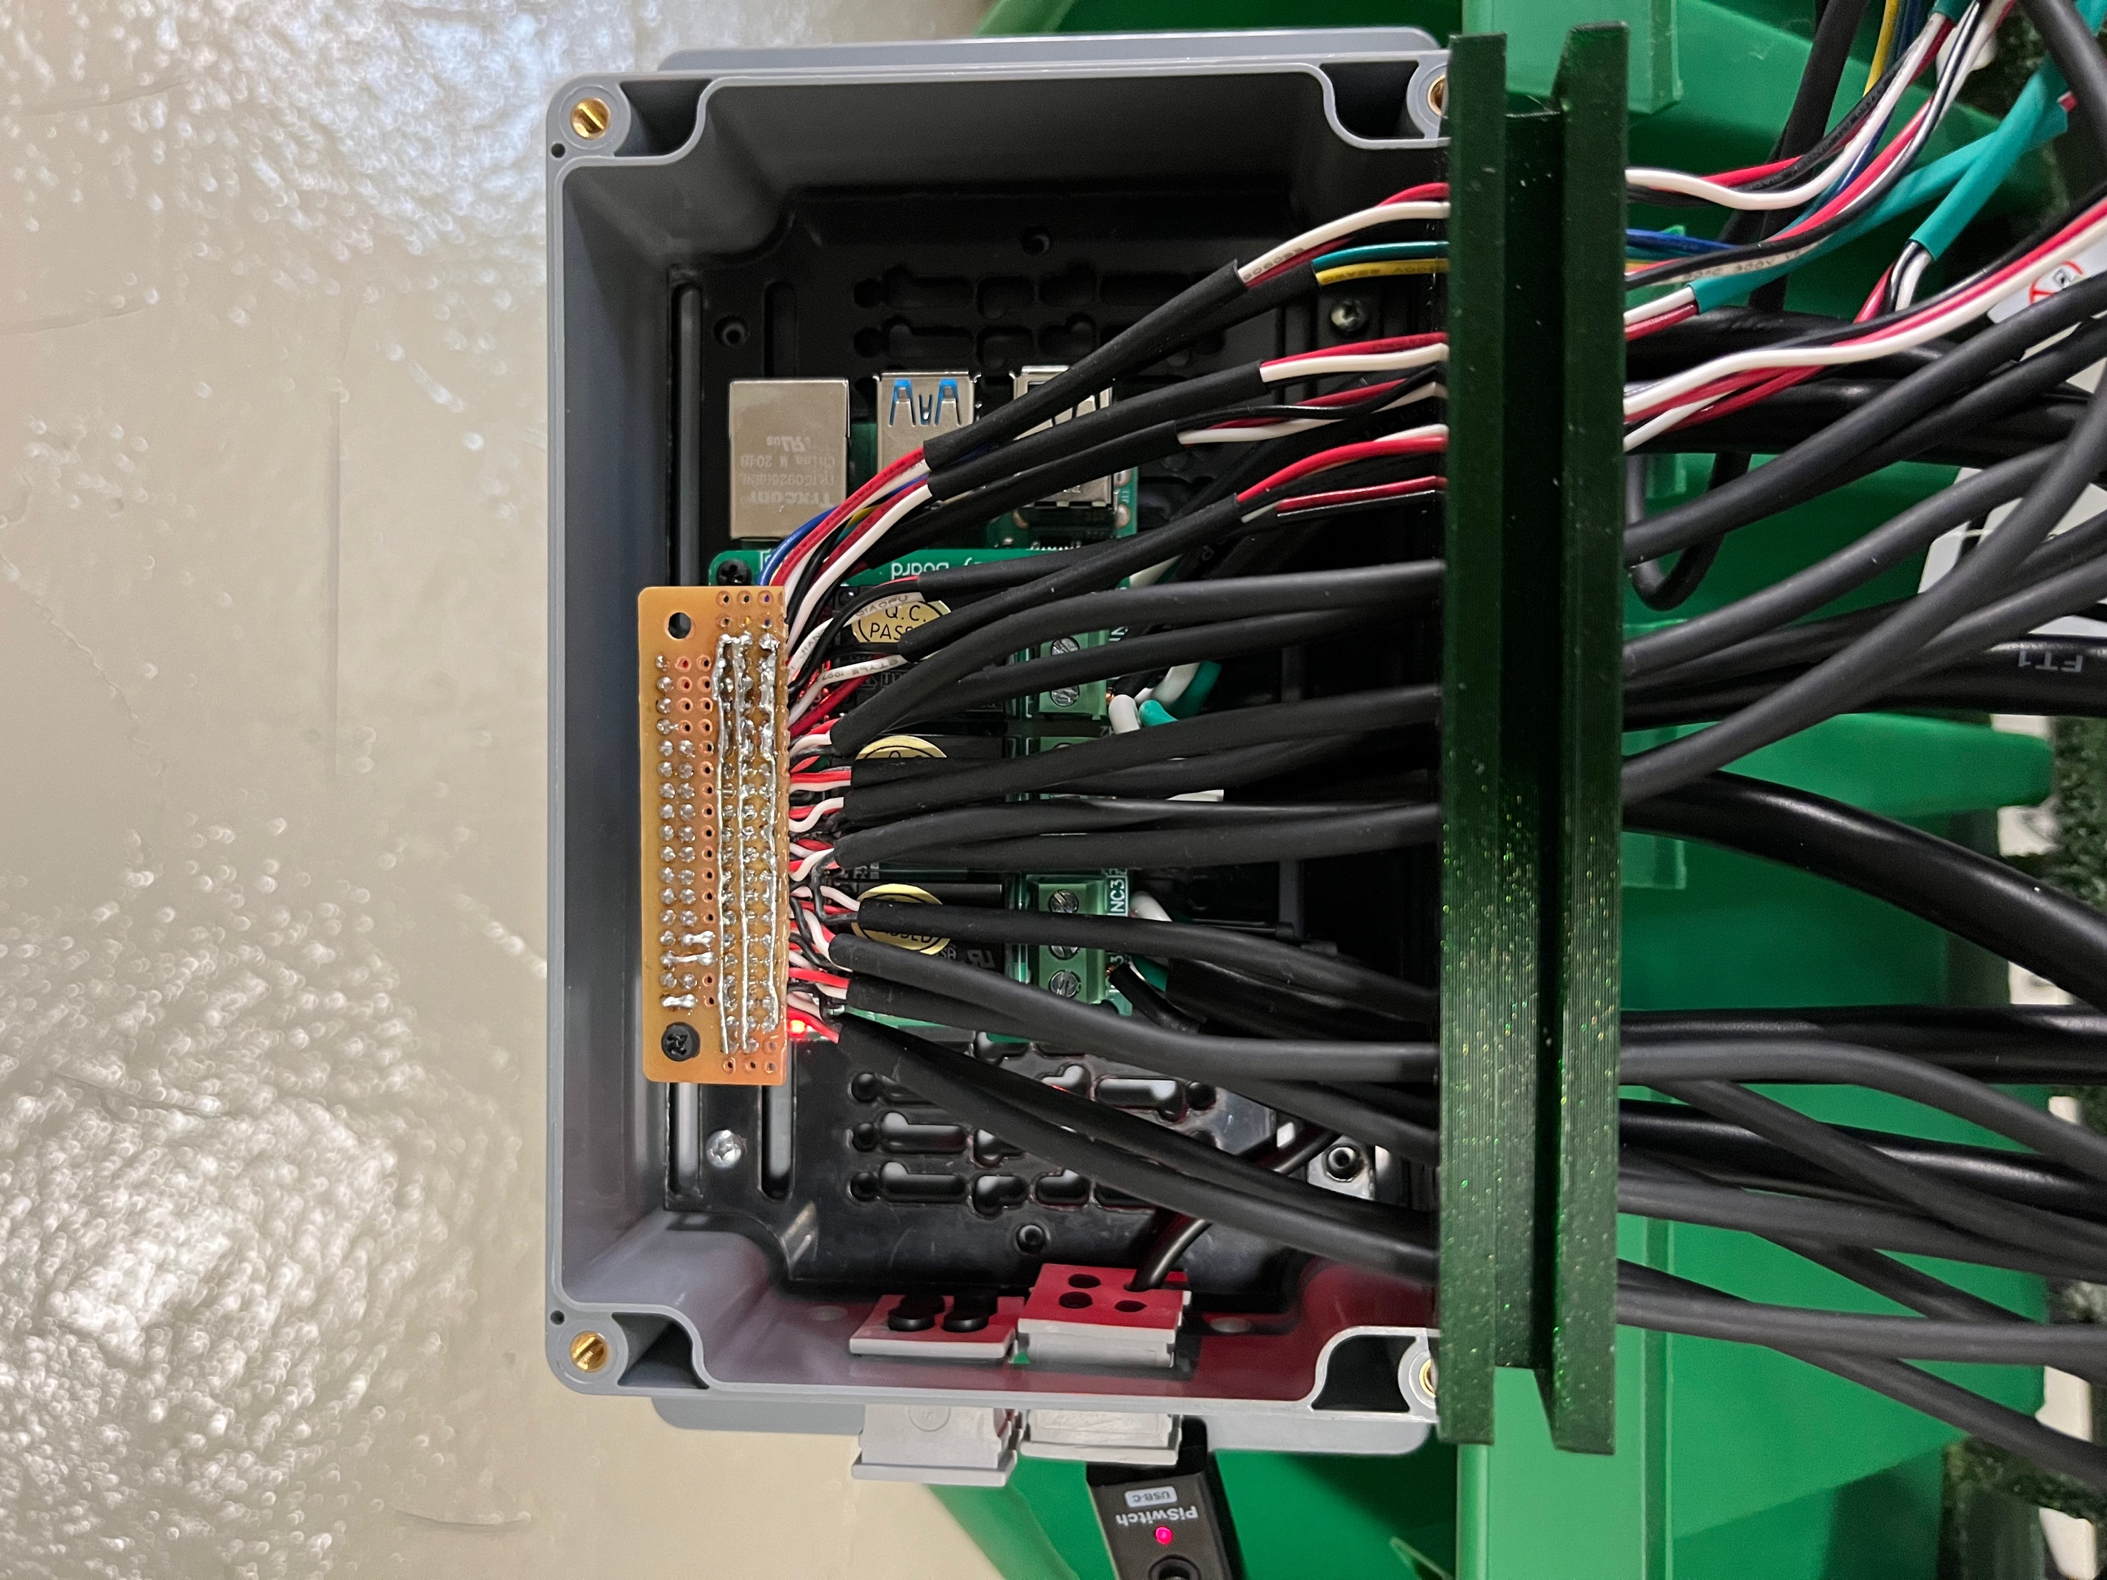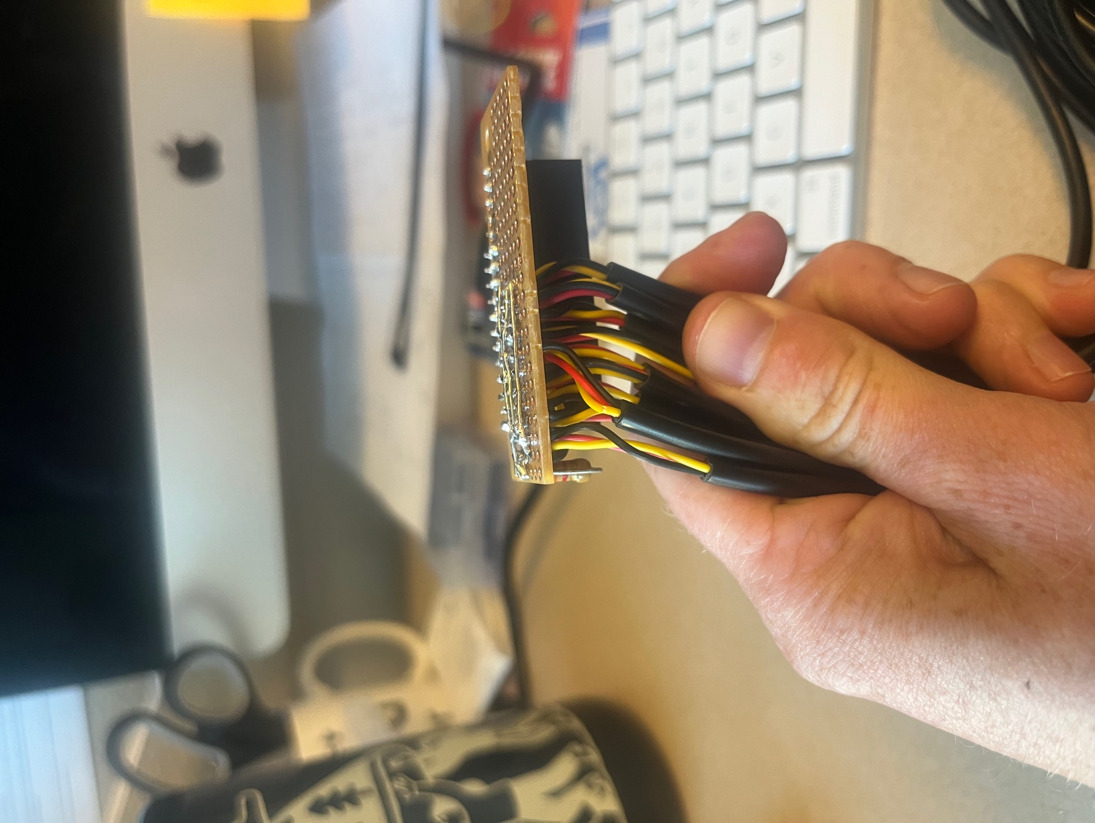

Figure CC. Top and side view of Perma-Proto HAT with all components soldered.

For more information about using DS18B20 temperature sensors with the RPi, read this tutorial: <https://www.circuitbasics.com/raspberry-pi-ds18b20-temperature-sensor-tutorial/>.

If you are still itching for more knowledge, check out these two posts about interfacing multiple DS18B20 sensors with the RPi: <https://www.hackster.io/vinayyn/multiple-ds18b20-temp-sensors-interfacing-with-raspberry-pi-d8a6b0>, and <https://blog.cavelab.dev/2019/10/rpi-ds18b20-temp-sensors/>.

**6. Assembling the system**

Stack the Relay HAT on top of the Rasperry Pi, and then stack the Perma-Proto HAT on top of your Relay HAT (Figure DD). Use nylon screws to carefully secure the three boards to each other. Place this set up inside your favorite waterproof case (example [lower-cost option](https://www.target.com/p/rubbermaid-brilliance-food-storage-container/-/A-53696326) and [higher-cost option](https://sixfab.com/product/raspberry-pi-ip54-outdoor-iot-project-enclosure/)). Now, you are ready to work on the code!

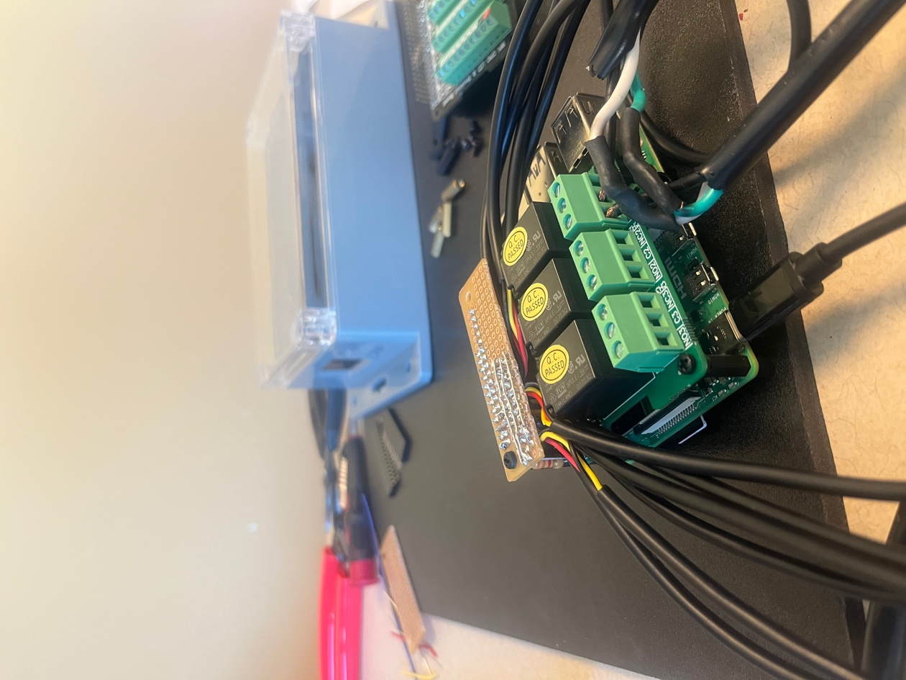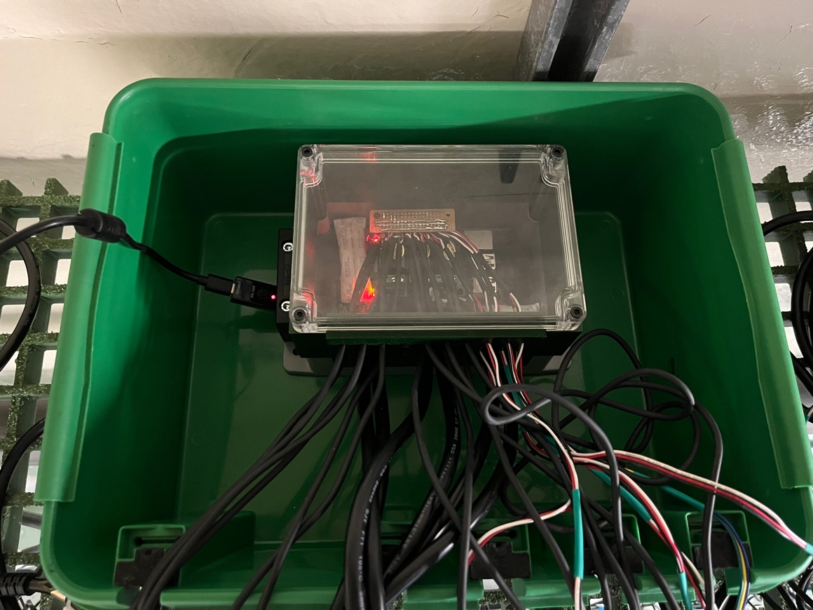

Figure DD. Fully assembled system (left) inside waterproof housing (right).

**7. Adapting the code to your experiment**

The project GitHub repository includes all the Python scripts you need to get started with your own MHWsim experiment.

1. Download all of the .py files in [code/python/](https://github.com/ameliaritger/MHWsim/tree/main/code/python) onto your Raspberry Pi. Also download the temperature profile (“mhw_profile.csv”; for testing purposes, you can delete this file or replace it as needed) contained within the same folder.
2. Run main.py, and make note of any errors that pop up. Debug as needed.
3. If the code throws no errors, then begin making adjustments. Run the program often to check for errors!

A brief description of each script can be found below (in alphabetical order):

**Alert.py** This code